主题：奥运奖牌

题型：柱状图

The chart below shows the total number of Olympic medals won by twelve different countries.

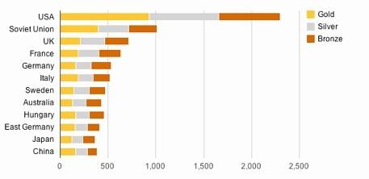

满分范文：

The bar chart compares twelve countries in terms of the overall number of medals that they have won at the Olympic Games.

It is clear that the USA is by far the most successful Olympic medal winning nation. It is also noticeable that the figures for gold, silver and bronze medals won by any particular country tend to be fairly similar.

The USA has won a total of around 2,300 Olympic medals, including approximately 900 gold medals, 750 silver and 650 bronze. In second place on the all-time medals chart is the Soviet Union, with just over 1,000 medals. Again, the number of gold medals won by this country is slightly higher than the number of silver or bronze medals.

Only four other countries - the UK, France, Germany and Italy - have won more than 500 Olympic medals, all with similar proportions of each medal colour. Apart from the USA and the Soviet Union, China is the only other country with a noticeably higher proportion of gold medals (about 200) compared to silver and bronze (about 100 each).